GUIDE FOR THE VMIBE/AAIBE SOFTWARE UPGRADE
- The establishment for VMIBE/AAIBE Monitor Program
- RS-232C cable
  - PC/Notebook
  - VMIBE/AAIBE Board
The one side of Rs-232 cable should be connected to a VMIBE/AAIBE, and
the other side of it should be connected to a PC.
- After setting up, turn on the system, the initial screen of VMIBE/AAIBE Monitor Program will be displayed on the hyper terminal.

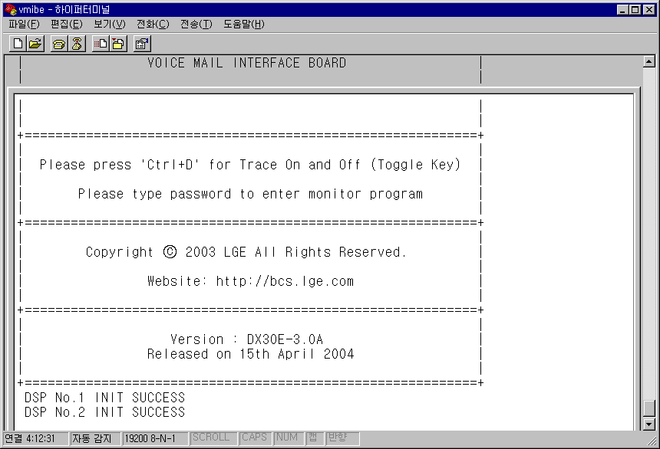
- VMIBE

- AAIBE
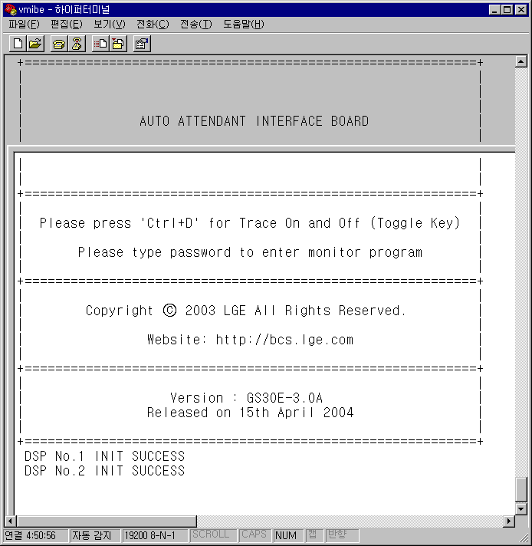

- Please type the password (‘millionire’). With correct password, you can see the screen as shown below.
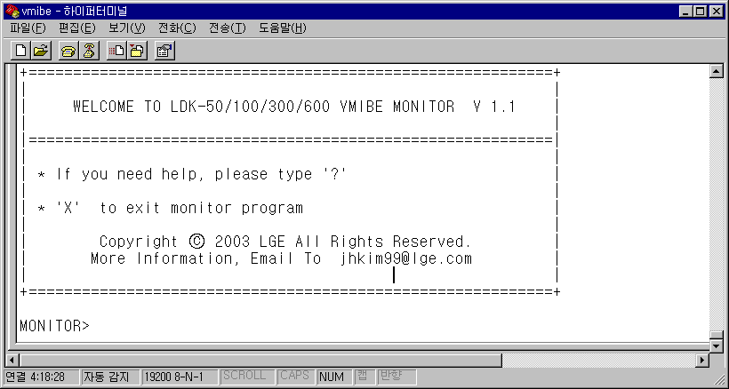

- If you type the character “?”, you can see the monitor Command List.
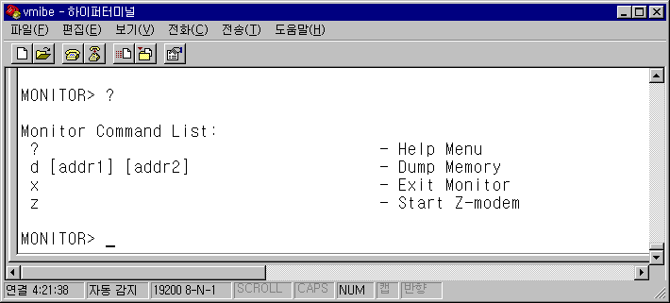

- The command for software upgrade is ‘z’.
If you type the character ‘z’, you can see the following screen.
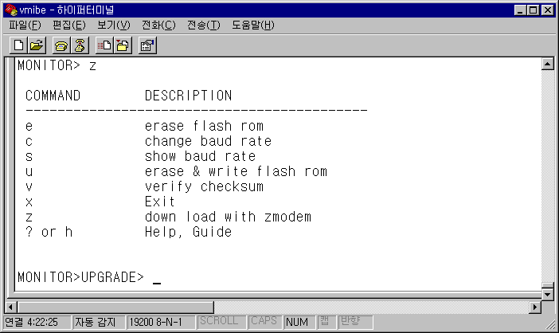

- Type the character ‘z’ once again, and the monitor program will ask the “yes” or “no” of z-modem execution. If you type the character ‘y(yes)’, it is displayed the comment ‘NAND Flash erasure has been finished..’.
And then, click the menu tab ‘Transfer (T)’ on the hyper terminal screen,
Select the menu ‘Transfer files (S)’
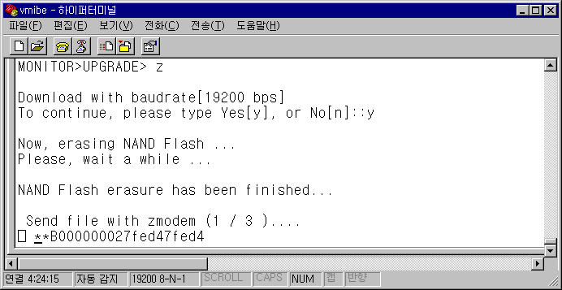
- Search and enter the path of the upgrading software and click the Send (S).
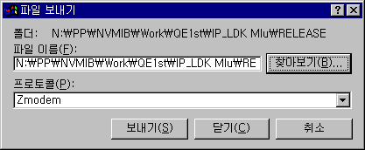
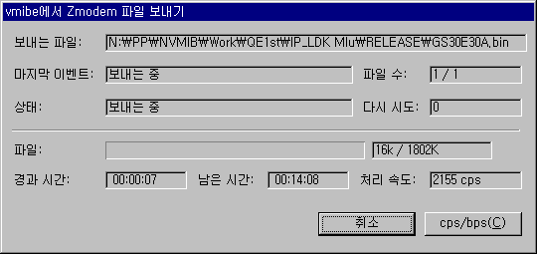
- Transmission will be on via Z-modem as the following screen,. Total estimated time of transmission is about 15 or 16 minutes (Baud Rate 19200).

- Type the character ‘y’ after completing download. The 2nd, 3rd, and 4th LED of VMIBE/AAIBE will be on and off during Flash ROM erasure. Subsequently, whole LED will be on and off while inspecting Flash ROM. Finally, the 5th, 6th, 7th, and 8th LED of VMIBE/AAIBE will be on and off during software upgrade on Flash ROM.
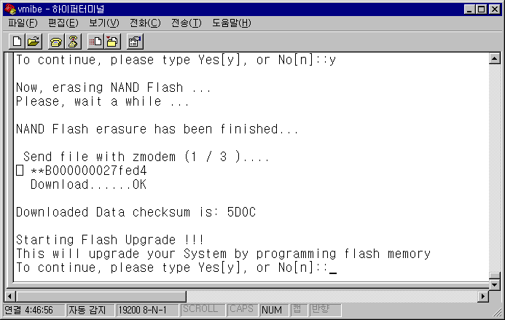
- As soon as the software upgrading is done, VMIBE/AAIBE will be reset automatically. Then, the initial screen will be displayed again.

